Aquatic Ecosystem Rehabilitation Plan
Part of the Aquatic Ecosystem Rehabilitation Process
Version 1.0

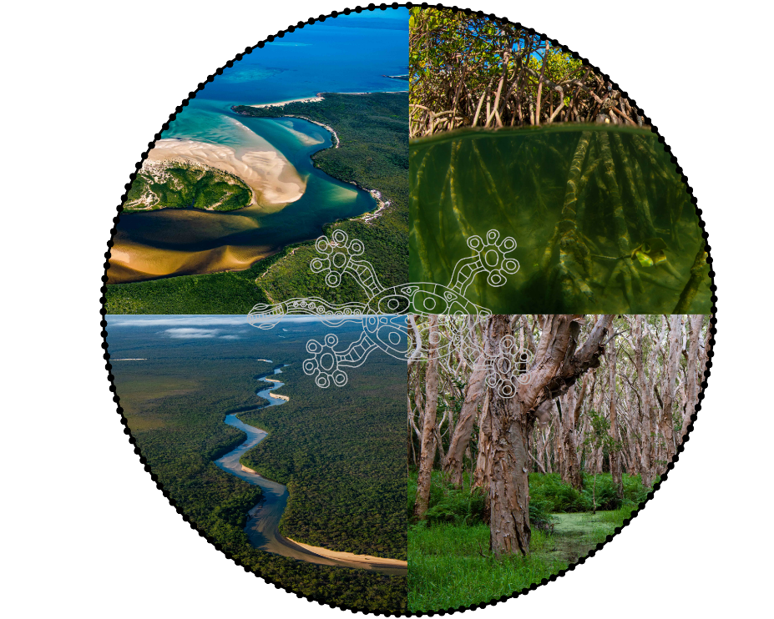

Image above depicts aquatic ecosystems throughout Queensland, top left quadrant - Olive River, top right quadrant - stilted mangroves, bottom right quadrant - melaleuca wetlands, and bottom left quadrant - Jardine River, overlayed by a freshwater long-neck turtle representing the connection between land and water. Turtle designed by John Locke. Photos by Gary Cranitch, Queensland Museum. Image compiled by Trent Munns.
Table of Contents
Rehabilitation Plan Introduction 4
How to use this Rehabilitation Plan 4
Triggers and initiatives for rehabilitation 5
Step 1: Understand whole-of-system and values 6
Step 2 – Based on Step 1, determine need and objective/s 7
Need and objective/s of the Rehabilitation Project 8
Step 3: Review needs and objectives 10
Step 4: Identify a mix of management interventions 11
Step 5: Produce detailed design 12
Step 6: Implementation 13
Step 7: Maintenance, monitoring, evaluation, adaptation, and sharing 14

Aquatic Ecosystem Rehabilitation Plan Introduction
The Aquatic Ecosystem Rehabilitation Plan (Rehabilitation Plan) operationalises the Aquatic Ecosystem Rehabilitation Process (Rehabilitation Process). Using this template will ensure all steps of the Rehabilitation Process are covered, from planning through implementation, to monitoring, maintenance and sharing of the findings. It can be used in combination with the condition assessment monitoring plan in WetCAT.
The seven-steps of the Rehabilitation Process provides a transparent approach to aquatic ecosystem rehabilitation. It is based on the Whole-of-System, Values-Based Framework (The Framework) and provides a comprehensive and integrated, values-based approach to aquatic ecosystem rehabilitation management. The Rehabilitation Process and the underpinning Framework have been designed to ensure that management decisions are informed by linking an understanding of the biophysical components (parts) and processes of aquatic ecosystems to the broader landscape, and to an understanding of the ecosystem services society derives from the aquatic ecosystem. This enables consideration of the value of these services to different beneficiaries and the threats and pressures on them.

How to use this Rehabilitation Plan
In this template, there are brief explanations of each Step of the Rehabilitation Process.

Where applicable, use the suggested formats to fill in this template as you develop the Rehabilitation Plan. Areas that are applicable to be filled out, with details relating to the specific site are highlighted in green, with suggested grey text to guide the suggested content for that section.

Refer back to the Rehabilitation Process for further information on filling out the template at each Step.

Figure 1 – Example section of template for specific, site-based, content
Identify services (see Step 2 – Identify existing and potential ecosystem services)
- Example: Rice, other leafy vegetables, or sugarcane grown in or adjacent to a wetland
Identify threats (see Pressures)
- Example: Nutrients
Note: To delete any tip (such as this), select it and start typing. If you’re not yet ready to add your own text, select a tip and press spacebar to remove it.
If you lose the examples and need to see them again, re-download the Aquatic Ecosystem Rehabilitation Plan.

Triggers and initiatives for rehabilitation
Aquatic ecosystem rehabilitation (rehabilitation) can be triggered by an event or begin through an initiative to address a responsibility or a need. Natural triggers can include disasters such as cyclones, floods and fire. Societal triggers and initiatives can include the need to protect at-risk infrastructure, market mechanisms, and drivers such as government policy, legislation or planning requirements (e.g. environmental offsets, water quality improvement and biodiversity protection).
More information on triggers and initiatives can be found here.
See also: Key principles for rehabilitation
Record triggers and initiatives below.

Trigger/Initiative | Comments
Floods | Can result in risk to land and infrastructure from erosion and deposition.  Note: To delete any tip (such as this), select it and start typing. If not yet ready to add your own text, select a tip and press spacebar to remove it.
Legal obligations | Can include the requirement to remove an invasive weed or maintaining a protected species. It can also include the need to rehabilitate an area due to illegal actions.

Step 1: Understand whole-of-system and values
The Whole-of-System, Values-Based Framework (the Framework) involves identifying the components and processes that make up an ecosystem at multiple scales (spatial and temporal), understanding how these components and processes give rise to ecosystem services (services), and identifying and understanding the values (including intrinsic) and people (stakeholders, beneficiaries) associated with an ecosystem.
Applying the Framework when planning for rehabilitation means that any management interventions are more likely to succeed. Rehabilitation activities that are aimed at parts of an ecosystem, with little or no consideration of impacts to the whole ecosystem or catchment, run the risk of unexpected and undesired outcomes.
More information on using the Framework for rehabilitation can be found here.
Use the Aquatic Ecosystem Rehabilitation Mapping Report for key information about the system and site.
Understand whole-of-system, services, values, beneficiaries and stakeholders for the broader system

Note: To delete any tip (such as this), select it and start typing. If you’re not yet ready to add your own text, select a tip and press spacebar to remove it.

Step 2 – Based on Step 1, determine need and objective/s
The clearer the objectives for rehabilitation, the easier it is to identify and implement management actions. An understanding of the proposed rehabilitation site and its immediate surrounding landscape should be undertaken to determine needs and objectives. The objectives should be linked to the desired outcome, which can be based on the services or values to be achieved. More information on Step 2 can be found here.
Systems (Components and Processes) : Understanding the type of system that is being rehabilitated reveals its components and processes. This information needs to be considered within the context of Step 1 and informed by the classification and condition of the site.
Identify existing and potential ecosystem services: Ecosystem services (services) and intrinsic and existence values are derived from the interaction between the components and processes of an ecosystem. Understanding the services at a site will directly impact the aims and objectives of a rehabilitation project.
Identify stakeholders and values for beneficiaries: Beneficiaries benefit from ecosystem services provided by the environment. However, not all people in the system are beneficiaries and some stakeholders may not benefit from, or are negatively impacted by, a service. Identifying and documenting stakeholders and beneficiaries and how they are affected by or benefit from an ecosystem enables clearer objectives to be set for any rehabilitation process.
Identify existing and potential threats, pressures and opportunities: Pressures can result from underlying human activities and natural processes or components at a variety of scales. Understanding current and emerging pressures to a rehabilitation site will allow for proactive management and minimise risks that the rehabilitation activity will not be effective.
Systems (Components and Processes)
Example: Riverine, Lacustrine, Palustrine, or Marine/Estuarine
Note: To delete any tip (such as this), select it and start typing. If you’re not yet ready to add your own text, select a tip and press spacebar to remove it.
Describe system parts – COMPONENTS
For example:
Vulnerable species
Rainfall
Topography
Geology
Understand how the system works - PROCESSES
For example:
Chemical processes
Water processes (Hydrology)

Identify existing and potential ecosystem services
- For example: Sugarcane grown in or adjacent to a wetland
- For example: Intrinsic or existence value
- List scale at which service applies, for example: temporal and spatial scales
Identify stakeholders and values for beneficiaries
- List of Beneficiaries (positively impacts by services listed above)
  - For example, landholders
  - For example, community (recreational)
- List of Stakeholders (those who are directly impacted by and/or influence decision-making)
  - For example, Local governments
  - For example, funding body

Identify existing and potential threats, pressures and opportunities
- List of potential pressures on the system
  - For example, upstream impacts to downstream – high flows
- Identify potential and current threats and pressures
  - For example, loss of connectivity on waterway due to infrastructure

Need and objective/s of the Rehabilitation Project

Objectives should be linked to the desired outcomes of the rehabilitation, which may be based on the services or values to be achieved. The clearer the objectives for rehabilitation, the easier it is to identify and implement management interventions More information here.
- List need/s
- List objective/s
- Ensure objectives developed are Specific, Measurable, Attainable, Relevant and Time-based (SMART) and use Structured Decision Making practices.

Step 3: Review needs and objectives
The original intent of a Rehabilitation Plan may change over time, especially after undertaking an assessment of the system as a whole. Using the information that has been gathered about the system, the need for rehabilitation and/or the underlying objectives, are re-evaluated. More information here.
Are the need and objectives still correct? Is there enough information to make a decision?
For example, the desired ecosystem services, condition or value is unachievable with current constraints (i.e. financial, or existing land use)
The anticipated cause of the degradation may be found to be incorrect, therefore changing rehabilitation objectives
List Objectives below.

 | Need/objective | Reassess or proceed? | Considerations

Step 4: Identify a mix of management interventions

Has Step 3 been completed? If so, list Management Interventions that compliment objectives.
Engagement, extension and education should be part of all interventions, but the degree will differ with the project. Best management practices should be applied first as these can reduce the need for other types of management intervention. (more information here)
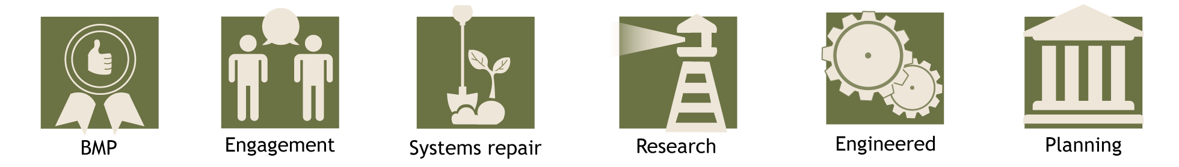
Pick a mix of management intervention/s
Note – identify possible management interventions. Decisions about which will be implemented will be decided in Steps 5 and 6.

For example – Bank battering, grass chutes, revegetation

Step 5: Produce detailed design
Once the mix of management interventions that address the objectives have been identified it is necessary to develop, document and cost a detailed design plan More information here.
Develop and document Detailed design, including:
☐ | Check legal obligations and approvals
☐ | Condition Assessment Monitoring Plan (done as part of Step 2)
☐ | Access considerations (private property, legal considerations, safety (i.e. after rain)
☐ | Relevant experts engaged
☐ | Existing and future pressures considered
☐ | Develop Communication Plan (Reporting and sharing plan)
☐ | Stakeholders and beneficiaries included in Detailed design
☐ | Staging of interventions (for example, action lists)
☐ | Costing and resources
☐ | Develop Project Timeline (incorporate seasonal information)
☐ | Site preparation considerations (e.g. plant selection, signage)
☐ | Maintenance design
☐ | Detailed design is documented and stored appropriately
☐ | Workplace Health and Safety and public safety addressed
☐ | Risk of unacceptable outcomes considered

Complete checklist and provide details below about Detailed Design (including contact details)
Access notes and Mapping Report

Step 6: Implementation
The implementation of the project designed in step 5 can include: on-ground works; systems repair; applied research; engagement, education and awareness; applied research and monitoring. More information here.
Where is the detailed design saved and kept?
What approvals have been sought and approved?
☐ | What expert advice is needed?
☐ | Health and safety considerations and public safety
☐ | Has the project plan been well articulated to those implementing it on site, and are there clear lines of communication?
☐ | Has baseline monitoring information been collected prior to starting works to benchmark and demonstrate change (CAMP)?
☐ | How does the site need to be prepared before works can commence?
☐ | Are the weather and flow conditions optimal for the intervention?
☐ | Additional considerations (example – who has authority, who will be there, biosecurity implications)
☐
☐
☐
☐

Step 7: Maintenance, monitoring, evaluation, adaptation, and sharing
After the implementation of the intervention, it is tempting to consider that the project is complete. However, long term maintenance and monitoring is required to evaluate progress towards the objectives. Evaluation will help determine if adaptation of the management approach is required. Once the evaluation has shown clear results these can be shared. More information here.
☐ | Monitoring and maintenance post implementation:  Notes and considerations
☐ | Evaluation of the intervention:  Notes and considerations
☐ | Adaptation of the intervention:  Notes and considerations
☐ | Sharing successes and learnings:  Notes and considerations
☐ | Reflecting on the whole-of-system goals:  Notes and considerations
☐ | Additional considerations

